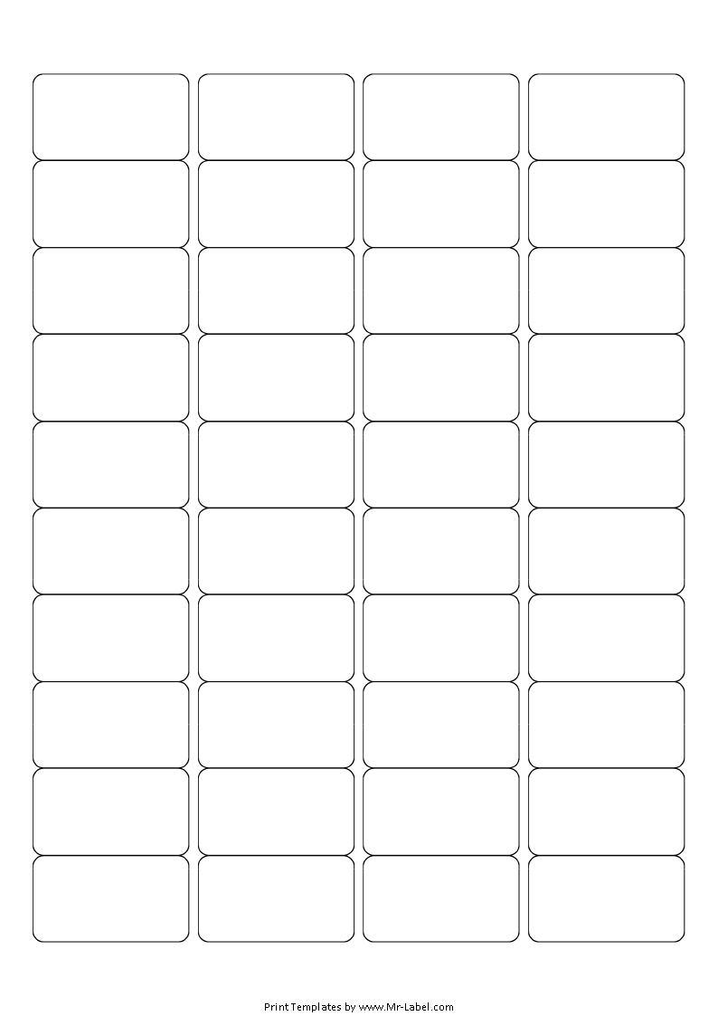  Mr-Label  SEE BIG FROM SMALL |  | Mr-Label  SEE BIG FROM SMALL |  | Mr-Label  SEE BIG FROM SMALL |  | Mr-Label  SEE BIG FROM SMALL
Mr-Label  SEE BIG FROM SMALL |  | Mr-Label  SEE BIG FROM SMALL |  | Mr-Label  SEE BIG FROM SMALL |  | Mr-Label  SEE BIG FROM SMALL
Mr-Label  SEE BIG FROM SMALL |  | Mr-Label  SEE BIG FROM SMALL |  | Mr-Label  SEE BIG FROM SMALL |  | Mr-Label  SEE BIG FROM SMALL
Mr-Label  SEE BIG FROM SMALL |  | Mr-Label  SEE BIG FROM SMALL |  | Mr-Label  SEE BIG FROM SMALL |  | Mr-Label  SEE BIG FROM SMALL
Mr-Label  SEE BIG FROM SMALL |  | Mr-Label  SEE BIG FROM SMALL |  | Mr-Label  SEE BIG FROM SMALL |  | Mr-Label  SEE BIG FROM SMALL
Mr-Label  SEE BIG FROM SMALL |  | Mr-Label  SEE BIG FROM SMALL |  | Mr-Label  SEE BIG FROM SMALL |  | Mr-Label  SEE BIG FROM SMALL
Mr-Label  SEE BIG FROM SMALL |  | Mr-Label  SEE BIG FROM SMALL |  | Mr-Label  SEE BIG FROM SMALL |  | Mr-Label  SEE BIG FROM SMALL
Mr-Label  SEE BIG FROM SMALL |  | Mr-Label  SEE BIG FROM SMALL |  | Mr-Label  SEE BIG FROM SMALL |  | Mr-Label  SEE BIG FROM SMALL
Mr-Label  SEE BIG FROM SMALL |  | Mr-Label  SEE BIG FROM SMALL |  | Mr-Label  SEE BIG FROM SMALL |  | Mr-Label  SEE BIG FROM SMALL
Mr-Label  SEE BIG FROM SMALL |  | Mr-Label  SEE BIG FROM SMALL |  | Mr-Label  SEE BIG FROM SMALL |  | Mr-Label  SEE BIG FROM SMALL

