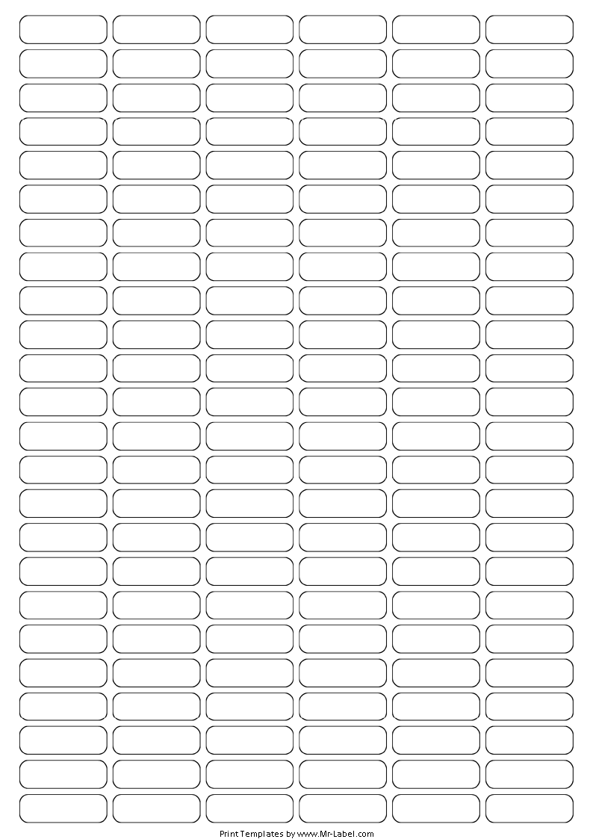  Mr-Label | Mr-Label | Mr-Label | Mr-Label | Mr-Label | Mr-Label
SEE BIG FROM SMALL | SEE BIG FROM SMALL | SEE BIG FROM SMALL | SEE BIG FROM SMALL | SEE BIG FROM SMALL | SEE BIG FROM SMALL
Mr-Label | Mr-Label | Mr-Label | Mr-Label | Mr-Label | Mr-Label
SEE BIG FROM SMALL | SEE BIG FROM SMALL | SEE BIG FROM SMALL | SEE BIG FROM SMALL | SEE BIG FROM SMALL | SEE BIG FROM SMALL
Mr-Label | Mr-Label | Mr-Label | Mr-Label | Mr-Label | Mr-Label
SEE BIG FROM SMALL | SEE BIG FROM SMALL | SEE BIG FROM SMALL | SEE BIG FROM SMALL | SEE BIG FROM SMALL | SEE BIG FROM SMALL
Mr-Label | Mr-Label | Mr-Label | Mr-Label | Mr-Label | Mr-Label
SEE BIG FROM SMALL | SEE BIG FROM SMALL | SEE BIG FROM SMALL | SEE BIG FROM SMALL | SEE BIG FROM SMALL | SEE BIG FROM SMALL
Mr-Label | Mr-Label | Mr-Label | Mr-Label | Mr-Label | Mr-Label
SEE BIG FROM SMALL | SEE BIG FROM SMALL | SEE BIG FROM SMALL | SEE BIG FROM SMALL | SEE BIG FROM SMALL | SEE BIG FROM SMALL
Mr-Label | Mr-Label | Mr-Label | Mr-Label | Mr-Label | Mr-Label
SEE BIG FROM SMALL | SEE BIG FROM SMALL | SEE BIG FROM SMALL | SEE BIG FROM SMALL | SEE BIG FROM SMALL | SEE BIG FROM SMALL
Mr-Label | Mr-Label | Mr-Label | Mr-Label | Mr-Label | Mr-Label
SEE BIG FROM SMALL | SEE BIG FROM SMALL | SEE BIG FROM SMALL | SEE BIG FROM SMALL | SEE BIG FROM SMALL | SEE BIG FROM SMALL
Mr-Label | Mr-Label | Mr-Label | Mr-Label | Mr-Label | Mr-Label
SEE BIG FROM SMALL | SEE BIG FROM SMALL | SEE BIG FROM SMALL | SEE BIG FROM SMALL | SEE BIG FROM SMALL | SEE BIG FROM SMALL
Mr-Label | Mr-Label | Mr-Label | Mr-Label | Mr-Label | Mr-Label
SEE BIG FROM SMALL | SEE BIG FROM SMALL | SEE BIG FROM SMALL | SEE BIG FROM SMALL | SEE BIG FROM SMALL | SEE BIG FROM SMALL
Mr-Label | Mr-Label | Mr-Label | Mr-Label | Mr-Label | Mr-Label
SEE BIG FROM SMALL | SEE BIG FROM SMALL | SEE BIG FROM SMALL | SEE BIG FROM SMALL | SEE BIG FROM SMALL | SEE BIG FROM SMALL
Mr-Label | Mr-Label | Mr-Label | Mr-Label | Mr-Label | Mr-Label
SEE BIG FROM SMALL | SEE BIG FROM SMALL | SEE BIG FROM SMALL | SEE BIG FROM SMALL | SEE BIG FROM SMALL | SEE BIG FROM SMALL
Mr-Label | Mr-Label | Mr-Label | Mr-Label | Mr-Label | Mr-Label
SEE BIG FROM SMALL | SEE BIG FROM SMALL | SEE BIG FROM SMALL | SEE BIG FROM SMALL | SEE BIG FROM SMALL | SEE BIG FROM SMALL

