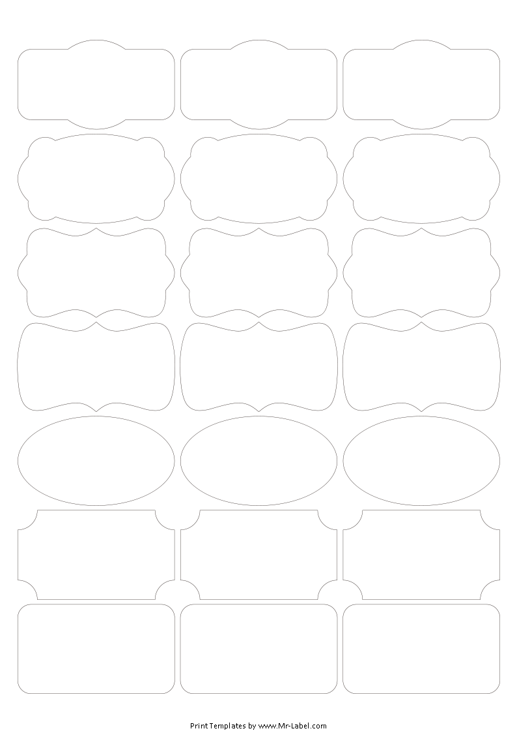  Mr-Label  SEE BIG FROM SMALL | Mr-Label  SEE BIG FROM SMALL | Mr-Label  SEE BIG FROM SMALL
Mr-Label  SEE BIG FROM SMALL | Mr-Label  SEE BIG FROM SMALL | Mr-Label  SEE BIG FROM SMALL
Mr-Label  SEE BIG FROM SMALL | Mr-Label  SEE BIG FROM SMALL | Mr-Label  SEE BIG FROM SMALL
Mr-Label  SEE BIG FROM SMALL | Mr-Label  SEE BIG FROM SMALL | Mr-Label  SEE BIG FROM SMALL
Mr-Label  SEE BIG FROM SMALL | Mr-Label  SEE BIG FROM SMALL | Mr-Label  SEE BIG FROM SMALL
Mr-Label  SEE BIG FROM SMALL | Mr-Label  SEE BIG FROM SMALL | Mr-Label  SEE BIG FROM SMALL
Mr-Label  SEE BIG FROM SMALL | Mr-Label  SEE BIG FROM SMALL | Mr-Label  SEE BIG FROM SMALL

