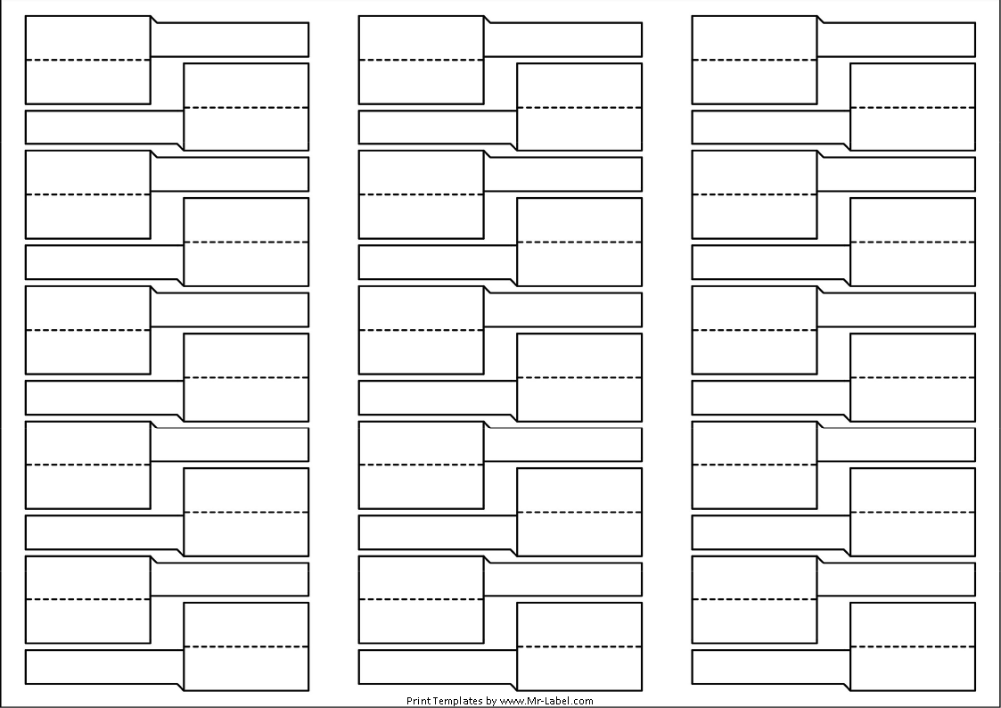  A Side 1 |  |  |  | A Side 11 |  |  |  | A Side 21
B Side 1 |  | A Side 2 |  | B Side 11 |  | A Side 12 |  | B Side 21 |  | A Side 22
 |  | B Side 2 |  |  |  | B Side 12 |  |  |  | B Side 22
asd
A Side 3 |  |  |  | A Side 13 |  |  |  | A Side 23
B Side 3 |  | A Side 4 |  | B Side 13 |  | A Side 14 |  | B Side 23 |  | A Side 24
 |  | B Side 4 |  |  |  | B Side 14 |  |  |  | B Side 24
A Side 5 |  |  |  | A Side 15 |  |  |  | A Side 25
B Side 5 |  | A Side 6 |  | B Side 15 |  | A Side 16 |  | B Side 25 |  | A Side 26
 |  | B Side 6 |  |  |  | B Side 6 |  |  |  | B Side 26
A Side 7 |  |  |  | A Side 17 |  |  |  | A Side 27
B Side 7 |  | A Side 8 |  | B Side 17 |  | A Side 18 |  | B Side 27 |  | A Side 28
 |  | B Side 8 |  |  |  | B Side 18 |  |  |  | B Side 28
A Side 9 |  |  |  | A Side 19 |  |  |  | A Side 29
B Side 9 |  | A Side 10 |  | B Side 19 |  | A Side 20 |  | B Side 29 |  | A Side 30
 |  | B Side 10 |  |  |  | B Side 20 |  |  |  | B Side 30

