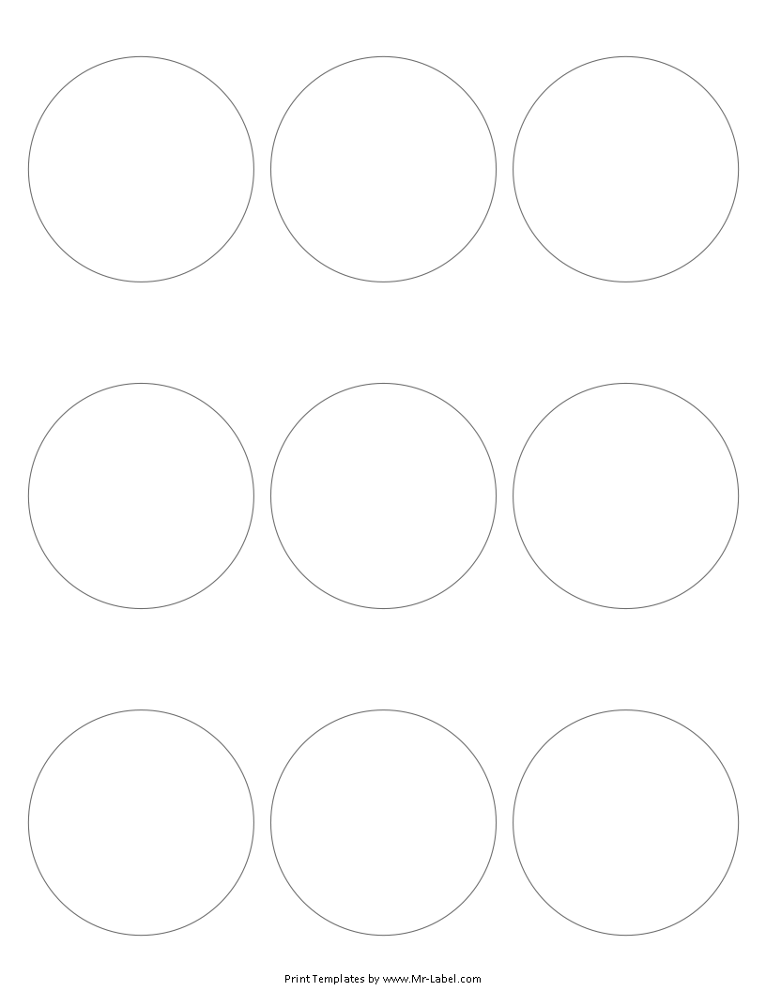  Mr-Label  See Big From Small |  | Mr-Label  See Big From Small |  | Mr-Label  See Big From Small
Mr-Label  See Big From Small |  | Mr-Label  See Big From Small |  | Mr-Label  See Big From Small
Mr-Label  See Big From Small |  | Mr-Label  See Big From Small |  | Mr-Label  See Big From Small

