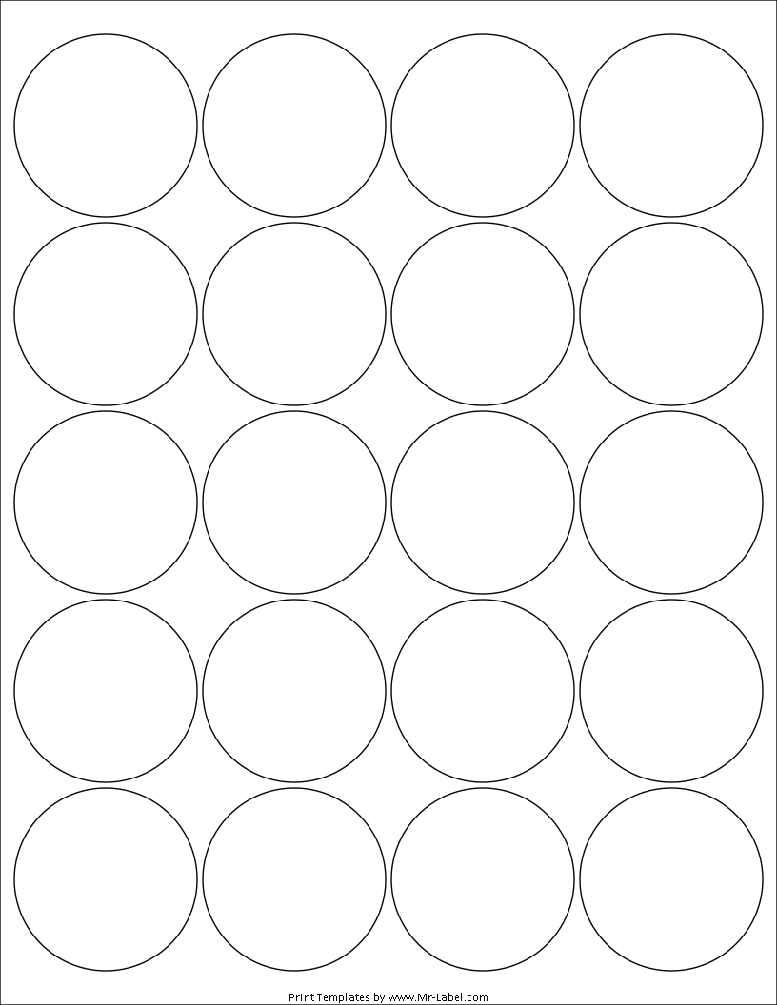  MR-Label  SEE BIG FROM SMALL | MR-Label  SEE BIG FROM SMALL | MR-Label  SEE BIG FROM SMALL | MR-Label  SEE BIG FROM SMALL
MR-Label  SEE BIG FROM SMALL | MR-Label  SEE BIG FROM SMALL | MR-Label  SEE BIG FROM SMALL | MR-Label  SEE BIG FROM SMALL
MR-Label  SEE BIG FROM SMALL | MR-Label  SEE BIG FROM SMALL | MR-Label  SEE BIG FROM SMALL | MR-Label  SEE BIG FROM SMALL
MR-Label  SEE BIG FROM SMALL | MR-Label  SEE BIG FROM SMALL | MR-Label  SEE BIG FROM SMALL | MR-Label  SEE BIG FROM SMALL
MR-Label  SEE BIG FROM SMALL | MR-Label  SEE BIG FROM SMALL | MR-Label  SEE BIG FROM SMALL | MR-Label  SEE BIG FROM SMALL

