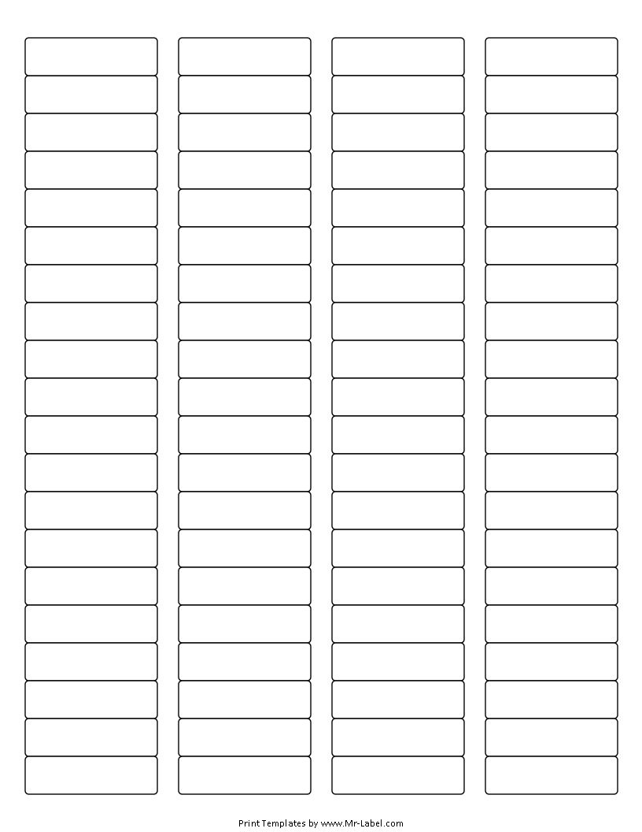  Mr-Label |  | Mr-Label |  | Mr-Label |  | Mr-Label
SEE BIG FROM SMALL |  | SEE BIG FROM SMALL |  | SEE BIG FROM SMALL |  | SEE BIG FROM SMALL
Mr-Label |  | Mr-Label |  | Mr-Label |  | Mr-Label
SEE BIG FROM SMALL |  | SEE BIG FROM SMALL |  | SEE BIG FROM SMALL |  | SEE BIG FROM SMALL
Mr-Label |  | Mr-Label |  | Mr-Label |  | Mr-Label
SEE BIG FROM SMALL |  | SEE BIG FROM SMALL |  | SEE BIG FROM SMALL |  | SEE BIG FROM SMALL
Mr-Label |  | Mr-Label |  | Mr-Label |  | Mr-Label
SEE BIG FROM SMALL |  | SEE BIG FROM SMALL |  | SEE BIG FROM SMALL |  | SEE BIG FROM SMALL
Mr-Label |  | Mr-Label |  | Mr-Label |  | Mr-Label
SEE BIG FROM SMALL |  | SEE BIG FROM SMALL |  | SEE BIG FROM SMALL |  | SEE BIG FROM SMALL
Mr-Label |  | Mr-Label |  | Mr-Label |  | Mr-Label
SEE BIG FROM SMALL |  | SEE BIG FROM SMALL |  | SEE BIG FROM SMALL |  | SEE BIG FROM SMALL
Mr-Label |  | Mr-Label |  | Mr-Label |  | Mr-Label
SEE BIG FROM SMALL |  | SEE BIG FROM SMALL |  | SEE BIG FROM SMALL |  | SEE BIG FROM SMALL
Mr-Label |  | Mr-Label |  | Mr-Label |  | Mr-Label
SEE BIG FROM SMALL |  | SEE BIG FROM SMALL |  | SEE BIG FROM SMALL |  | SEE BIG FROM SMALL
Mr-Label |  | Mr-Label |  | Mr-Label |  | Mr-Label
SEE BIG FROM SMALL |  | SEE BIG FROM SMALL |  | SEE BIG FROM SMALL |  | SEE BIG FROM SMALL
Mr-Label |  | Mr-Label |  | Mr-Label |  | Mr-Label
SEE BIG FROM SMALL |  | SEE BIG FROM SMALL |  | SEE BIG FROM SMALL |  | SEE BIG FROM SMALL

