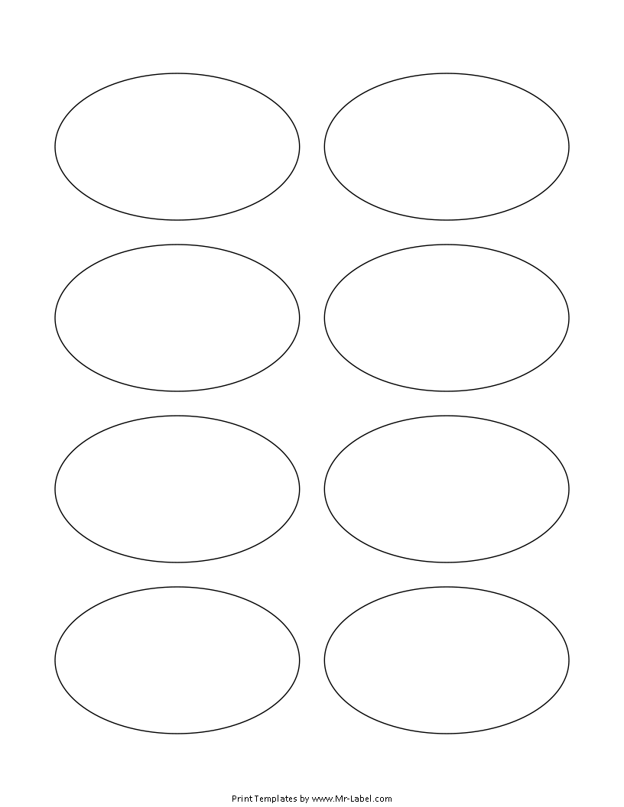  MR-Label  SEE BIG FROM SMALL |  | MR-Label  SEE BIG FROM SMALL
MR-Label  SEE BIG FROM SMALL |  | MR-Label  SEE BIG FROM SMALL
MR-Label  SEE BIG FROM SMALL |  | MR-Label  SEE BIG FROM SMALL
MR-Label  SEE BIG FROM SMALL |  | MR-Label  SEE BIG FROM SMALL

