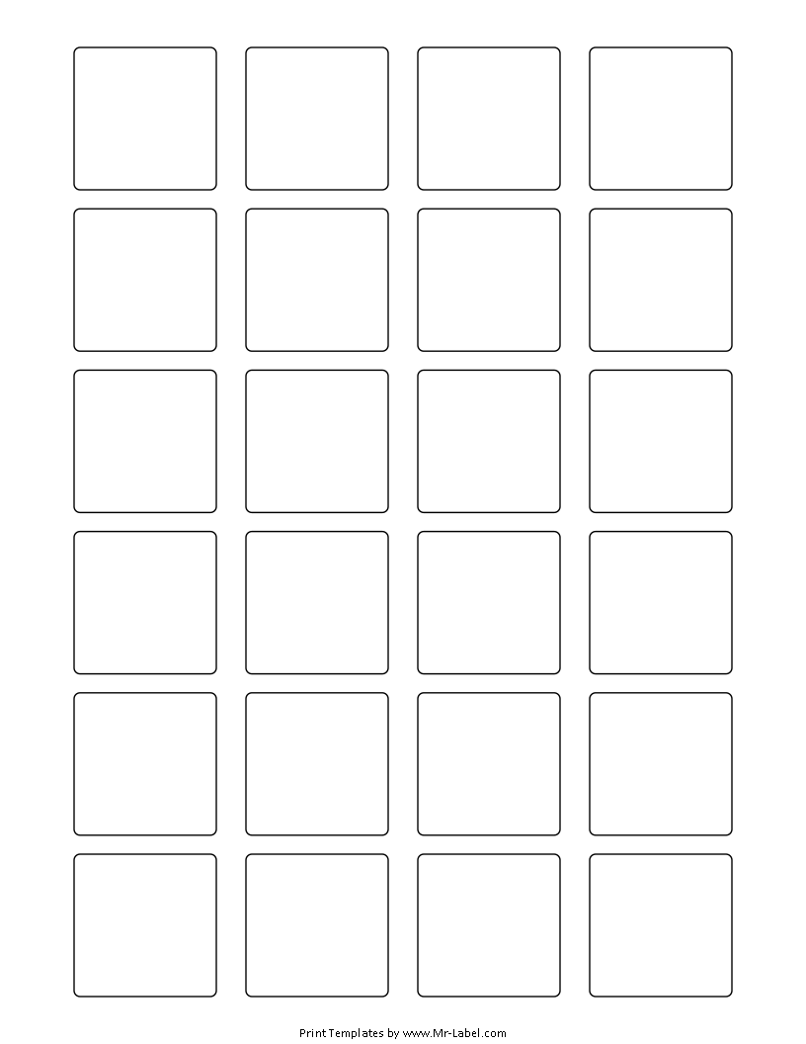  MR-Label |  | MR-Label |  | MR-Label |  | MR-Label
SEE BIG FROM SMALL |  | SEE BIG FROM SMALL |  | SEE BIG FROM SMALL |  | SEE BIG FROM SMALL
MR-Label |  | MR-Label |  | MR-Label |  | MR-Label
SEE BIG FROM SMALL |  | SEE BIG FROM SMALL |  | SEE BIG FROM SMALL |  | SEE BIG FROM SMALL
MR-Label |  | MR-Label |  | MR-Label |  | MR-Label
SEE BIG FROM SMALL |  | SEE BIG FROM SMALL |  | SEE BIG FROM SMALL |  | SEE BIG FROM SMALL

